Butterfly Tracking System (BTS)

Software Requirements Specification Document
Version No. 1.2
Project Document Revision History
Version Number | Date | Revision Author | Description of Revision
1.0 | 11/17/2015 | Issam Jassim | Initial Creation
1.1 | 11/20/2015 | Issam Jassim | Modified Functional Model and Description, Behavioral Model and Description
1.2 | 11/24/2015 | Issam Jassim, Yue Dai | Finished the whole SRS document

Table of Contents
1.1 Goals and objectives 5
1.2 Statement of scope 5
1.3 Software context 5
1.4 Major constraints 6
2.0 Usage scenario 6
2.1 User profiles 6
2.2 Use-cases 7
2.3 Special usage considerations 7
3.0 Data Model and Description 7
3.1 Data Description 7
3.1.1 Data objects 7
3.1.2 Data dictionary 8
4.0 Functional Model and Description 9
4.1 Description for Function n 9
4.1.1 Use case name 9
4.2 Software Interface Description 9
4.2.1 External machine interfaces 9
4.2.2 External system interfaces 9
4.2.3 Human interface 9
4.3 Use Case Diagrams 9
4.4 Sequence Diagrams 10
4.5 Communication Diagrams 10
5.0 Behavioral Model and Description 10
5.1 State Transition Diagrams 10
5.1.1 State Diagram for Retrieve Butterfly Reports (UC-1): 10
5.1.2 State Diagram for Session Management (UC-2): 11
5.1.3State Diagram Create Tagging/Sighting (UC-3): 11
5.1.4 State Diagram Update Tagging/Sighting (UC-4): 12
5.1.5 State Diagram Administration (UC-5): 12
5.1.6 State Diagram Submit and View Feedback (UC-6): 13
5.2 Activity Diagram 13
6.0 Restrictions, Limitations, and Constraints 13
7.0 Validation Criteria 13
7.1 Classes of tests 13
7.2 Expected software response 14
7.3 Performance bounds 14
8.0 Appendices 15
8.1 System traceability matrix 15
8.2 CRC Cards 15
8.3 Class UML Diagram 17
8.4 Context and Data Flow Diagrams 18

1.0 Introduction

1.1 Goals and objectives
The purpose of Butterfly Tracking System is to monitor migration patterns of butterflies around the globe in order to preserve their habitat and analyze their behavior. When butterflies are tagged, the time and location is entered into the database. The tagged butterflies can then be tracked by reporters who will record the time and location of each sighting and update the database accordingly. The database will maintain a full record for each tagged butterfly, which contains the tag number, date tagged, and all times and locations it was sighted thereafter. The system is to use the gathered information to generate various tabular and visual reports for its users. The final product must be intuitive and easy to use, so that people with little or no computer skills could easily use it.

1.2 Statement of scope
The Butterfly Tracking System will be implemented using a web-based interface so that it can be accessed using any modern web browser on any platform, including mobile devices, without the need of any additional software. Another benefit of such implementation is multi-user access to the system. The following is a list of core system functions:
- Maintain and display a list of taggers/reporters
- Maintain a list of user credentials for security and data integrity (Session Management)
- Allow taggers/reporters to add butterfly tagging/sighting information into the database
- Display various reports by different criteria (by tag number, tagger, reporter, location, or date)
- Allow users to upload/download daily tracking data files based on butterfly tag (Batch file)
- Given a coordinate and a radius (in miles) give a visual of all butterfly sightings in the region
- Provide a user-friendly visualization of the routes of butterflies
- Implement a real-time and intuitive dashboard
- Accept, store and display user comments and feedback

1.3 Software context
The goal of the Butterfly Tracking System is to bring together people that are interested in preserving butterflies’ habitat in order to try and stop their decline. The BTS will be a convenient web based application that will allow users to report butterfly taggings and sightings, as well and view and retrieve various reports that can help them analyze the butterflies’ migration habits and behavior. In order to preserve the integrity of the butterfly tracking information in the database and for security, only registered users can submit changes, but any visitor will be able to view all records and obtain specific records by inputting desired criteria without having to go through the entire list of records, thus saving time in finding desired information.

1.4 Major constraints
The biggest constraint for Butterfly Tracking system is time. This is mainly due to the team’s limited experience in software development. We could not find a particular software development environment that all team members were familiar with, so we expect a significant amount of time will be spent learning about a particular programming language. To meet the deadline, the team will focus on necessary functionalities of the system and once those are met additional features will be added if time permits.

2.0 Usage scenario

2.1 User profiles
Guest: Any user that visits the website. This type of user will not require an account and will have limited access to the system. Guests will be able to view or download butterfly tracking information, but will not be able to make any changes to the database.
Registered User: A user that has an active account in the system is considered a registered user. This type of user can report and update own butterfly taggings and sightings, as well as make changes to his or her account information.
Administrator: This type of user has the highest level of access to the system. Therefore, this user will be able to update all taggings and sightings, as well as manage all user accounts, which includes granting them administrator status.

2.2 Use-cases
The table below contains all Use cases and Use Case Summary and their corresponding document:
Use Case ID | Use Case Name | Document File Name
UC-1 | Retrieve Butterfly Reports | UC-1 v1.4.doc
UC-2 | Session Management | UC-2 v1.1.doc
UC-3 | Create Tagging/Sighting | UC-3 v1.1.doc
UC-4 | Update Tagging/Sighting | UC-4 v1.1.doc
UC-5 | Administration | UC-5 v1.2.doc
UC-6 | Submit and View Feedback | UC-6 v1.2.doc
 | Use Case Summary | Use Case Summary v1.1.doc

2.3 Special usage considerations
None.

3.0 Data Model and Description

3.1 Data Description

3.1.1 Data objects
The following Build ERD shows all the data entities along with their attributes:
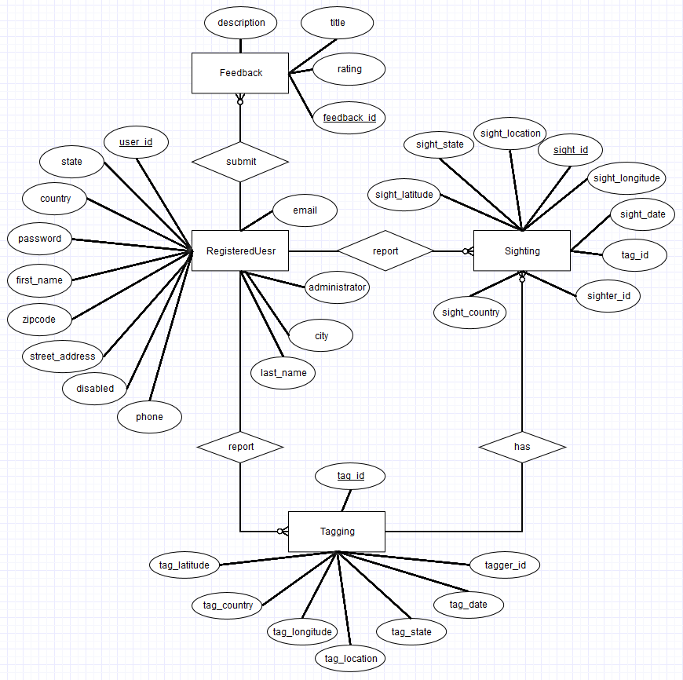
Diagram 3.1.1 Build ERD v1.0 11/22/2015

3.1.2 Data dictionary
See the “Sighting Data Dictionary v1.0.xlsx” file.

4.0 Functional Model and Description

4.1 Description for Function n

4.1.1 Use case name
See section 2.2 for details.

4.2 Software Interface Description
The software interface(s) to the outside world is (are) described.

4.2.1 External machine interfaces
Since the Butterfly Tracking System will run over the internet, all the hardware shall require to connect to the internet will be hardware interface for the system. Examples are Cable/DSL Modem, Router, Ethernet Cable, and so on.

4.2.2 External system interfaces
The Butterfly Tracking System will be able to process batch files containing any number of butterfly taggings and sightings. These files can be uploaded from any system that is connected to the internet with any modern browser installed.
Similarly, the system will enable its users to download batch files containing butterfly tracking information to their system, provided the conditions above are met.

4.2.3 Human interface
The user interface for the Butterfly Tracking System will be compatible with any modern browser, such as Microsoft Edge, Mozilla Firefox, Google Chrome, Apple Safari, Opera, and so on. The user interface will be implemented using tools such as JavaScript, Java Server Pages (JSP), JQuery, CSS 3, and HTML 5.

4.3 Use Case Diagrams
The Use Case Summary document contains all details and use case diagrams. See section 2.0 for more details.

4.4 Sequence Diagrams
See documents SD-1.doc through SD-6.doc for sequence diagrams for UC-1 through UC-6 respectively. For detailed use case specifications see section 2. 0.

4.5 Communication Diagrams
See image files CD-1.png through CD-6.png for communication diagrams for UC-1 through UC-6 respectively. For detailed use case specifications see section 2. 0.

5.0 Behavioral Model and Description
A description of the behavior of the software is presented.

5.1 State Transition Diagrams

5.1.1 State Diagram (SMD-1) for Retrieve Butterfly Reports (UC-1):
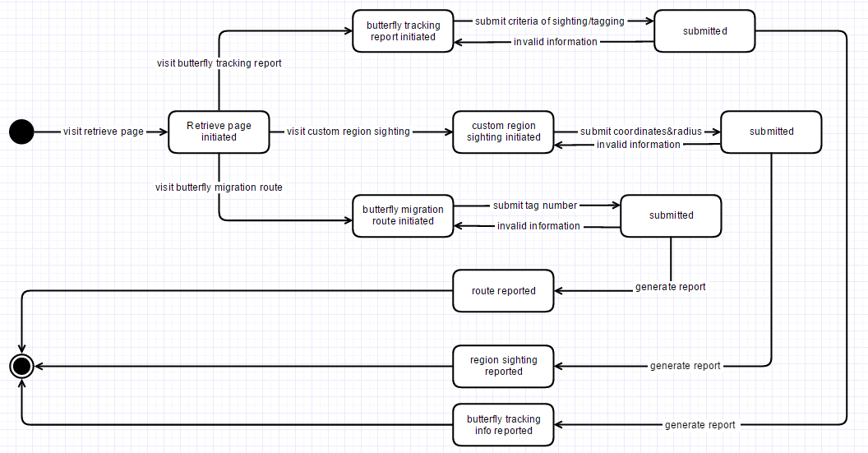
Diagram 5.1.1 SMD-1 version 1.0 11/23/2015

5.1.2 State Diagram (SMD-2) for Session Management (UC-2):
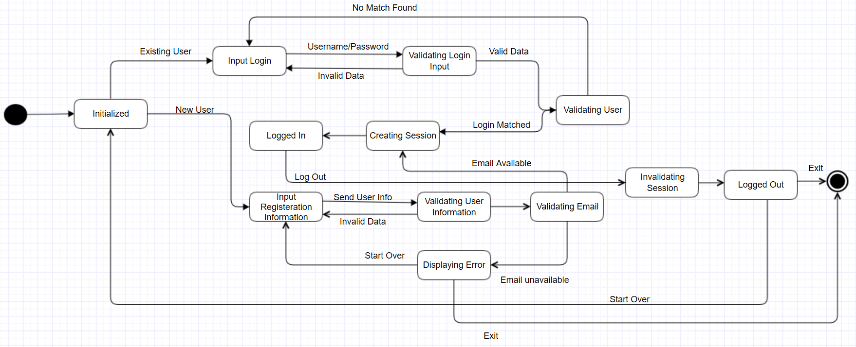
Diagram 5.1.2 SMD-2 version 1.0 11/23/2015

5.1.3State Diagram (SMD-3) for Create Tagging/Sighting (UC-3):
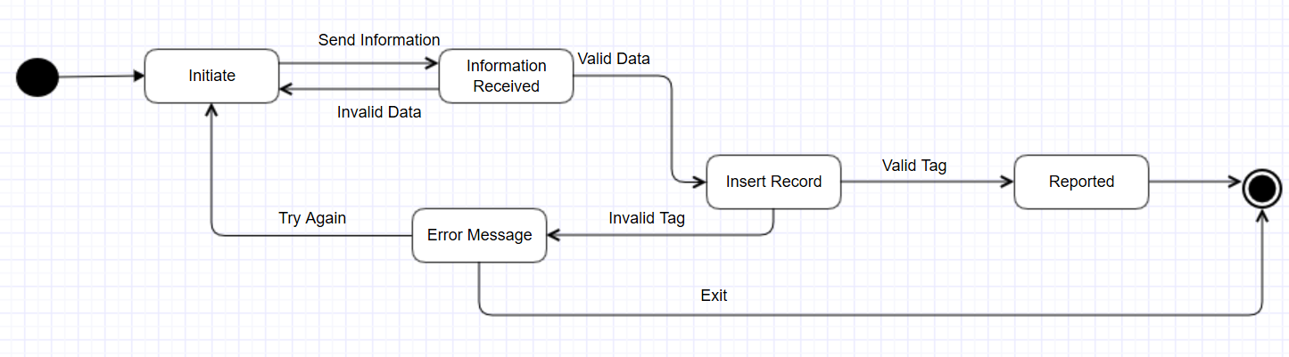
Diagram 5.1.3 SMD-3 version 1.0 11/23/2015

5.1.4 State Diagram (SMD-4) for Update Tagging/Sighting (UC-4):
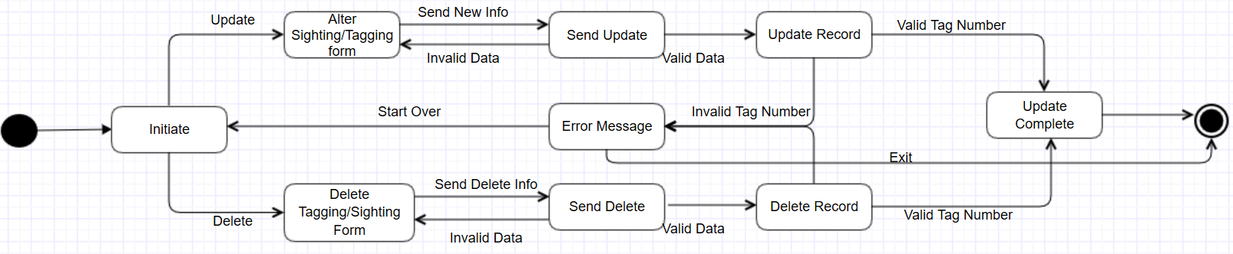
Diagram 5.1.4 SMD-4 version 1.0 11/23/2015

5.1.5 State Diagram (SMD-5) for Administration (UC-5):
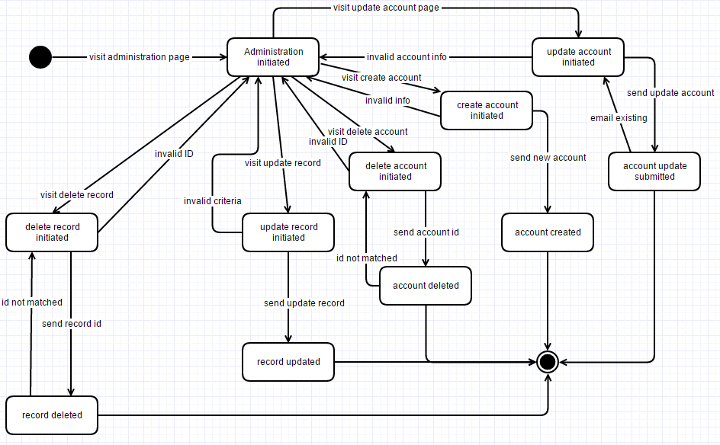
Diagram 5.1.5 SMD-5 version 1.0 11/23/2015

5.1.6 State Diagram (SMD-6) for Submit and View Feedback (UC-6):
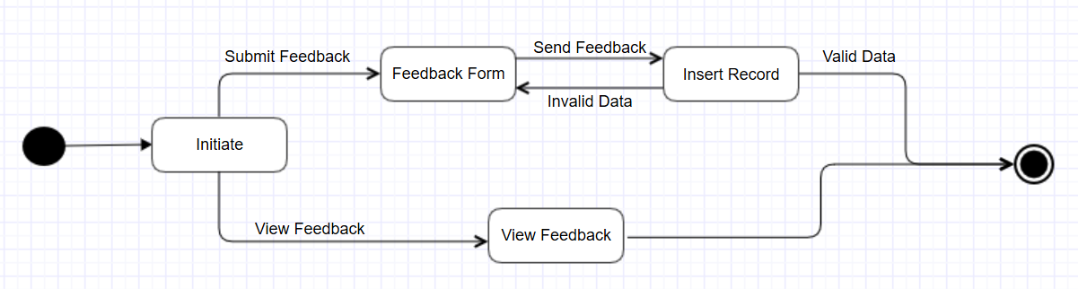
Diagram 5.1.6 SMD-6 version 1.0 11/23/2015

5.2 Activity Diagram
See Use Case Specification Documents for details. Section 2.2 lists all use case documents.

6.0 Restrictions, Limitations, and Constraints
None.

7.0 Validation Criteria

7.1 Classes of tests
The types of tests the team will perform during the development of the Butterfly Tracking System are as follows:
- Unit Testing: To test each and every part of the system in early stages and catch problems in every stage of the development. [1]
- Integration Testing: This will complement unit testing, in that it will allow us to combine multiple program units into one component and test them as a group to ensure program units work properly as a group as well as individually.
- Functional Testing: Applied to ensure each functionality satisfies the requirements regardless of the implementation.
- System Testing: This type of testing will be conducted on the entire system to ensure all requirements are properly met.
More emphasis will be made upon black box testing, and to achieve this we will maintain a usable system throughout the development process and will build upon this system and add functionalities in a maintainable fashion. Doing so will allow us to involve actual target users involved in early stages of the development process in order to get early feedback from users.

7.2 Expected software response
The time taken to login, report or update butterfly tagging or sighting, account management, and any administration task should not take more than 20 seconds from the time the action is initiated by the user until the action is completed. We want the users that use the Butterfly Tracking System to have a pleasant experience and minimize their wait time. However, retrieving various butterfly reports in the form of tables, maps, or files, and uploading and downloading batch files, will be heavily dependent on the size of the report/file, but all effort will be made to maximize the system’s efficiency and minimize user wait time.

7.3 Performance bounds
In addition to what was mentioned in 7.2 regarding system response time, the Butterfly Tracking System will be able to handle multiple connections at a time. The system will have enough resources to meet this requirement.

8.0 Appendices

8.1 System traceability matrix
See the document TraceabilityMatrix.xlsx.

8.2 CRC Cards [2]
Guest
Responsibilities | Collaborations
Register for an account | RegisteredUser
View Tagging Report | RetrieveButterflyReport
View Sighting Report | Feedback
Download Batch File
View/Submit Feedback

RegisteredUser
Responsibilities | Collaborations
View Tagging Report | RetrieveButterflyReport
View Sighting Report | Feedback
Download Batch File | CreateButterflySightingTagging
View/Submit Feedback | UpdateButterflySightingTagging
Report Sighting
Report Tagging
Update Sighting
Update Tagging

Administrator
Responsibilities | Collaborations
View Tagging Report | RetrieveButterflyReport
View Sighting Report | Feedback
View/Submit Feedback | CreateButterflySightingTagging
Report Sighting | UpdateButterflySightingTagging
Report Tagging | Administration
Update Sighting
Update Tagging
Manage User Accounts
Manage All Sightings
Manage All Taggings

Feedback
Responsibilities | Collaborations
Submit Feedback | Guest
View Feedback | RegisteredUser
 | Administrator

Sighting
Responsibilities | Collaborations
Submit Sighting | RetrieveButterflyReport
View Sighting | CreateButterflyTaggingSighting
Update Sighting | UpdateButterflySightingTagging
 | Administration

Tagging
Responsibilities | Collaborations
Submit Tagging | RetrieveButterflyReport
View Tagging | CreateButterflyTaggingSighting
Update Tagging | UpdateButterflySightingTagging
 | Administration

8.3 Class UML Diagram [3]
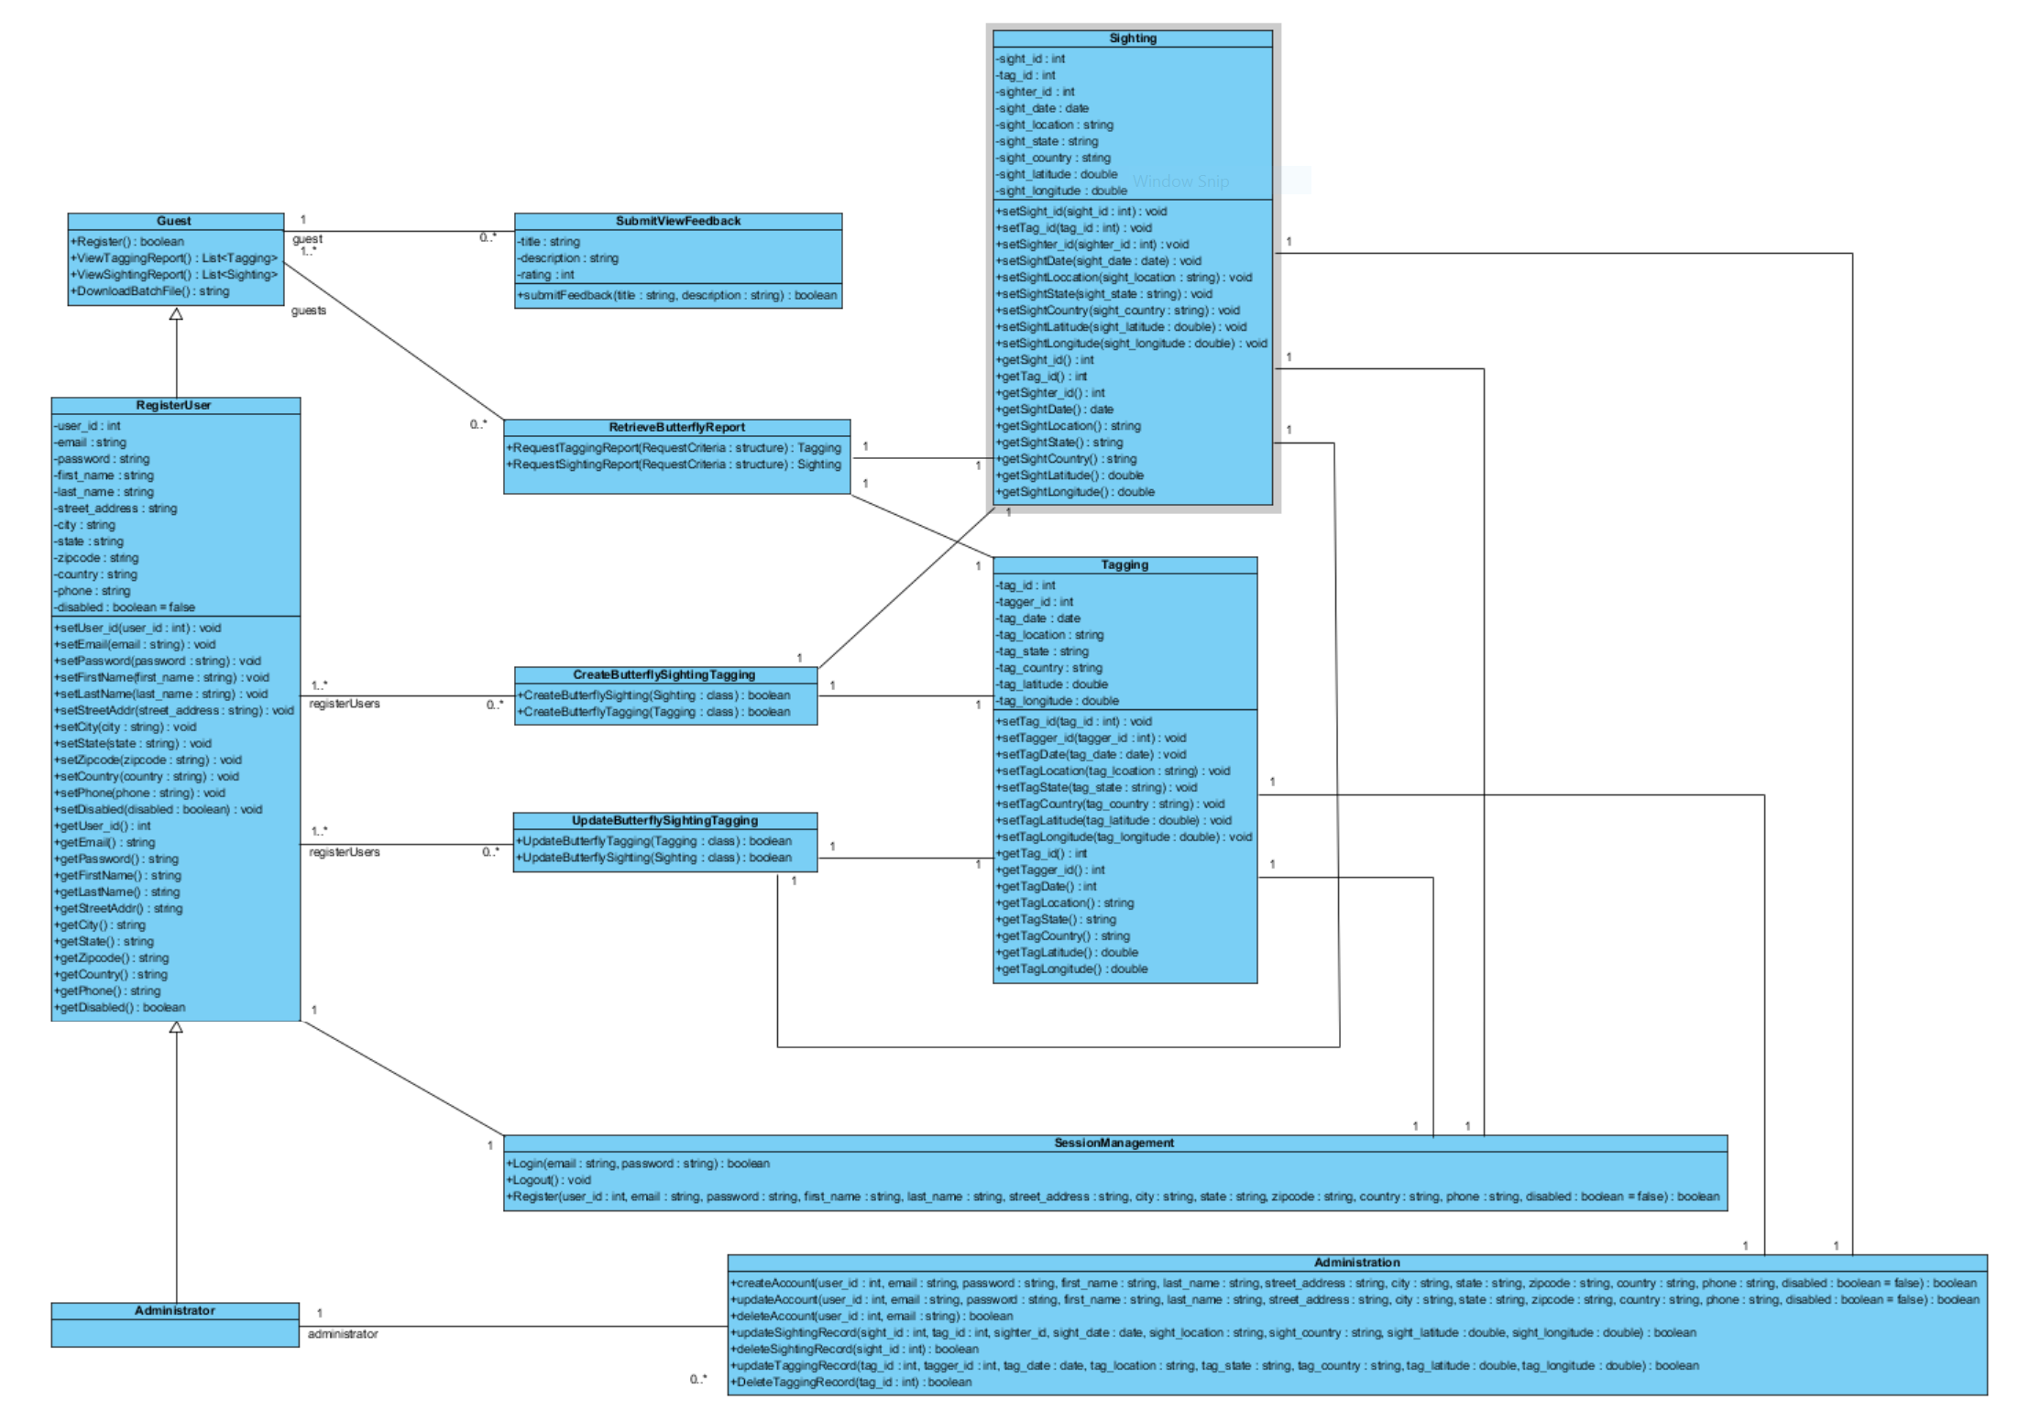

8.4 Context and Data Flow Diagrams
See Context Diagram.png, 0DFD.png, 1DFD.png. 2DFD.png, 3DFD.png, 4DFD.png, 5DFD.png, and 6DFD.png for all Context and Data Flow diagrams.
8.5 References

[1] “Unit Testing”, https://en.wikipedia.org/wiki/Unit_testing [Nov.26, 2015].
[2] Agile Alliance, “Crc Cards”, http://guide.agilealliance.org/guide/crc.html [Nov.28, 2015].
[3] VP Gallery, “Class Diagram”, http://www.visual-paradigm.com/VPGallery/diagrams/Class.html [Nov.27, 2015].

